- Wireless Networking

Q.1 List 3 popular Wi-Fi standards (e.g., 802.11n, 802.11ac, 802.11ax) and for each, write one key difference in speed or frequency band?

Answer
Wi-Fi Standard | Common Name | Frequency Band | Key Difference
- 802.11n | Wi-Fi 4 | 2.4 GHz and 5 GHz | Supports speeds up to about 600 Mbps.
- 802.11ac | Wi-Fi 5 | Mainly 5 GHz | Faster than 802.11n and supports higher speeds.
- 802.11ax | Wi-Fi 6 | 2.4 GHz and 5 GHz | Provides higher speed, better efficiency, and handles more devices.

802.11n works on both 2.4 GHz and 5 GHz.
802.11ac mainly uses 5 GHz and provides faster speed.
802.11ax is newer and performs better when many devices are connected.

Q.2 Draw a simple diagram (on paper or using any drawing tool) showing how your smartphone connects to the internet via a Wi-Fi router at home, labeling the wireless and wired parts of the network?

Answer

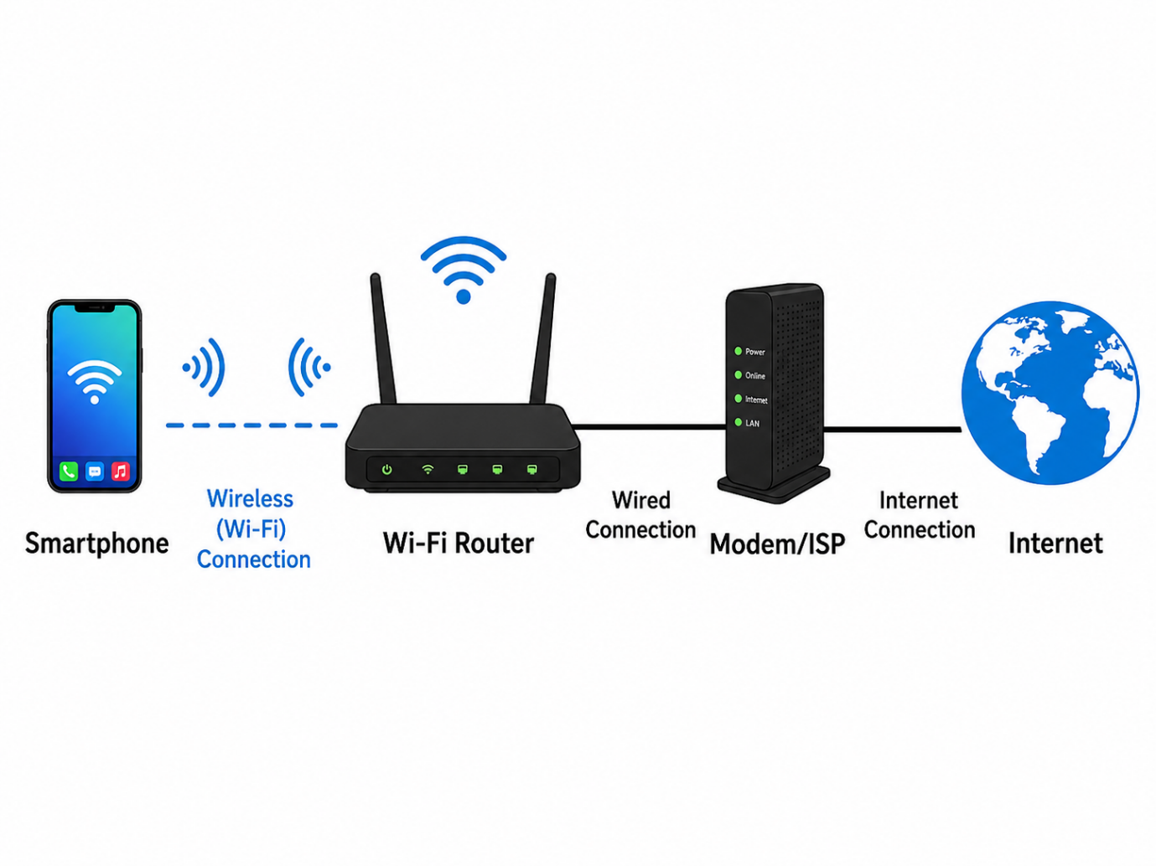

- The diagram shows how a smartphone connects to the internet through a home Wi-Fi network. The smartphone connects wirelessly to the Wi-Fi router. The router is then connected by a wired connection to the modem/ISP, which provides access to the internet.

Q3. Scan for available Wi-Fi networks using your laptop or phone, note down the SSID, signal strength, and security type (WPA2, WPA3, etc.) for at least 3 networks, and explain which one you would choose and why.<br><br><em><strong>Hint:</strong> Consider both signal strength and security when choosing.</em>?

Answer

- Wi-Fi Network Scan
I scanned for available Wi-Fi networks and noted the SSID, signal strength, and security type.
SSID | Signal Strength | Security Type
- Galaxy F15 5G 5DAF | 100% | WPA2-Personal
- RedmiNote 9 Pro Max | 82% | WPA2-Personal
- RedmiNote 13 5G | 74% | WPA2-Personal

- Preferred Network:
I would choose Galaxy F15 5G 5DAF because it has the strongest signal strength at 100% and uses WPA2-Personal security. This should provide a stable connection while also keeping the network protected.
- Conclusion:
While selecting a Wi-Fi network, both signal strength and security are important. A stronger signal provides better connectivity, while WPA2 or WPA3 security helps protect the network from unauthorized access.

Q.4 Explain in your own words what 'SSID hiding' is in Wi-Fi networks and discuss one advantage and one disadvantage of hiding your Wi-Fi SSID?

Answer

- SSID Hiding
SSID stands for Service Set Identifier, which is the name of a Wi-Fi network.
SSID hiding means the Wi-Fi router stops broadcasting its network name. Because of this, the network may not appear normally in the list of available Wi-Fi networks.
- Advantage
One advantage is that the Wi-Fi network becomes less visible to nearby users, so casual users may not immediately see it.
- Disadvantage
One disadvantage is that users must manually enter the Wi-Fi name to connect, which makes connection less convenient.
- Conclusion
SSID hiding can reduce the visibility of a Wi-Fi network, but it does not provide strong security by itself because the hidden network can still be detected using network scanning tools.

